Chapter 8 Rocks
extra worksheet 2: Types of sedimentary rock
Science understanding Logical/Mathematical, Visual/Spatial
This activity uses the four diagrams (Figures 8.2.1, 8.2.2, 8.2.3 and 8.2.4) that appear in your Pearson science 8 Student Book in Chapter 8.
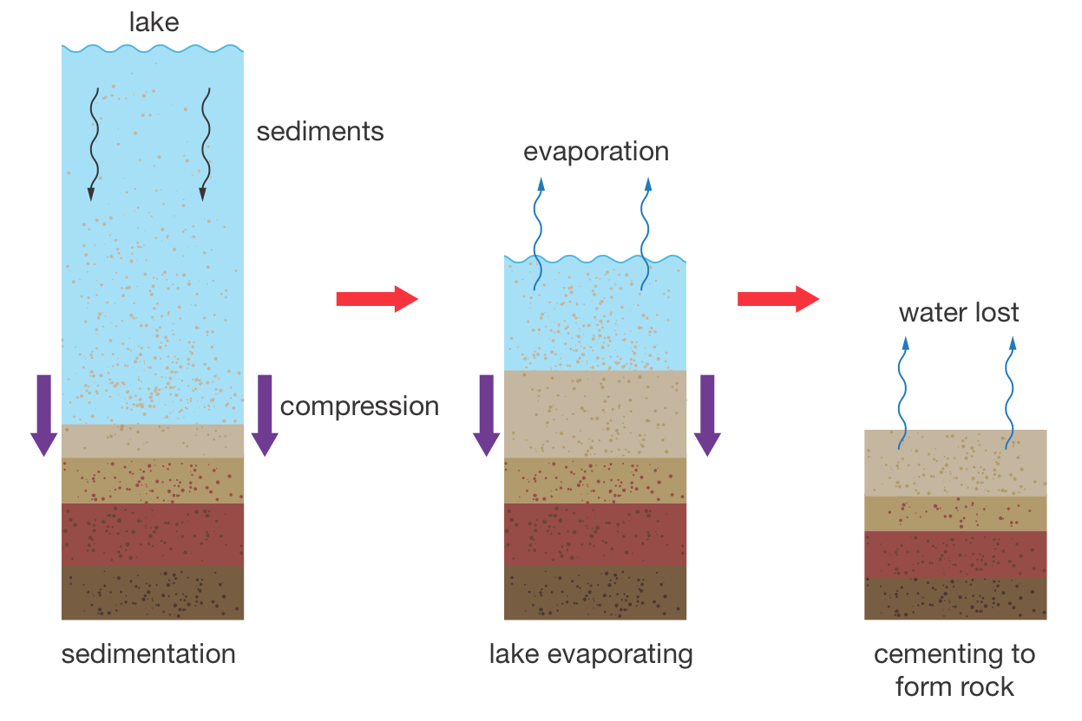
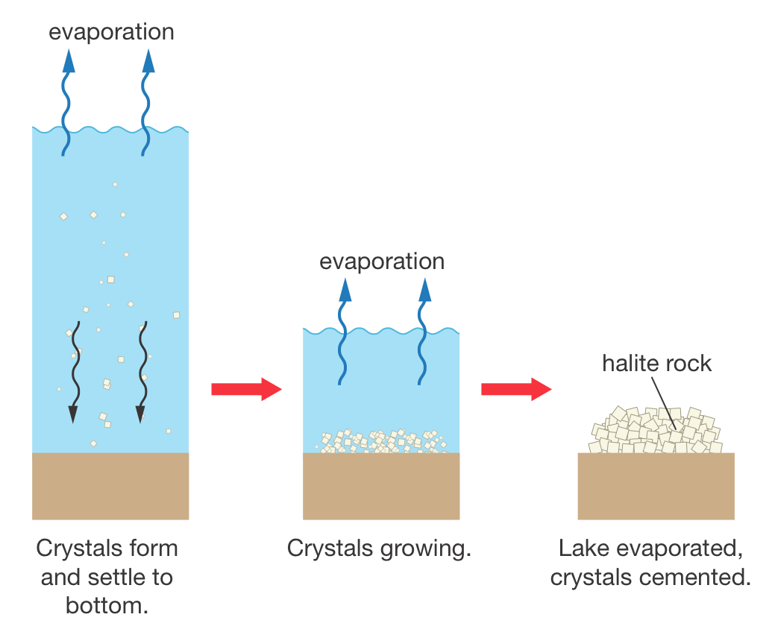

Figure 8.2.1 Figure 8.2.2

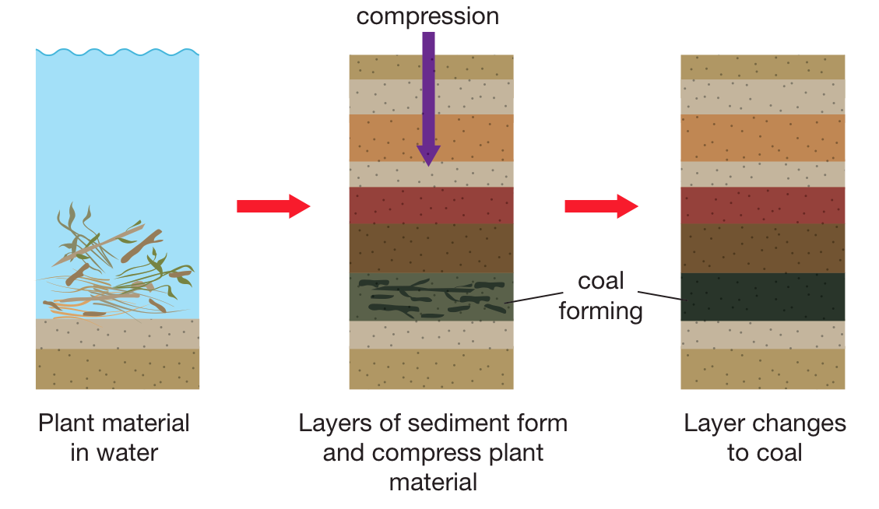

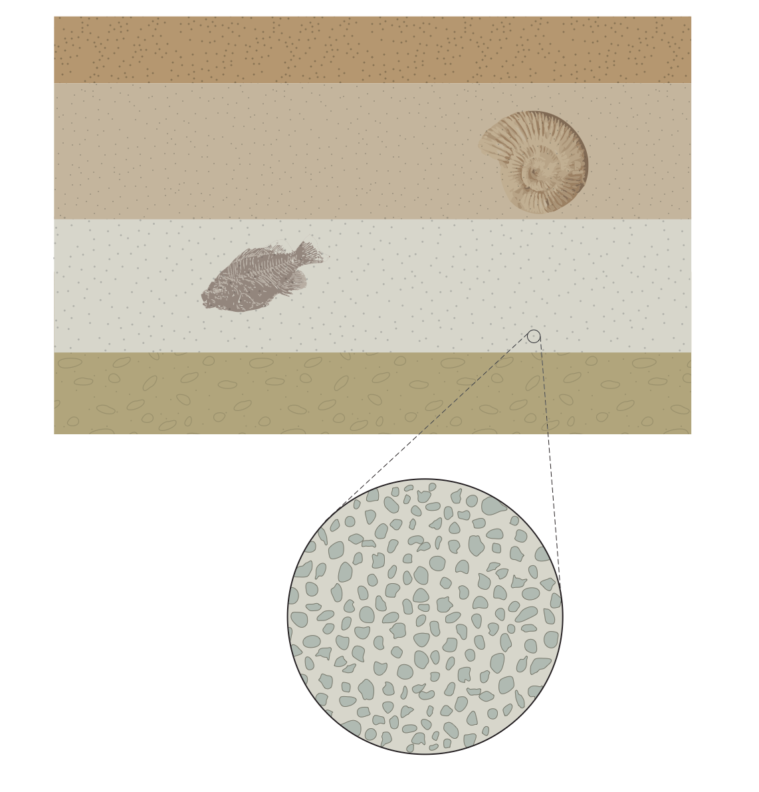

Figure 8.2.3 Figure 8.2.4

Questions
1 Identify the type of sedimentary rock formed in Figures 8.2.1, 8.2.2 and 8.2.3.

2 Identify the three key processes of formation of the sedimentary rock in Figure 8.2.1.

3 Describe the process of formation of the sedimentary rock in Figure 8.2.2.

4 Describe the process of formation of the sedimentary rock in Figure 8.2.3.

5 Explain what Figure 8.2.4 is showing.

